Effectiveness of Denmead Policies in Made NP

To help determine the scope and detail needed for review of the Neighbourhood Plan (NP) policies, it is important to understand how they have been used since the Plan was made. These comments and observations will help to understand which policies should be retained, how they could be strengthened and which policies may not be needed in the reviewed Plan. It is clear that some of the existing policies will need updating where circumstances have changed, and comments made below will also help to confirm this where that is thought to be the case.

Policy | Comments and observations  (for example, on use (frequency, how used, etc.), effectiveness and weaknesses, and suggested changes to strengthen)
 | Denmead PC | Winchester CC  (informal officer comments)
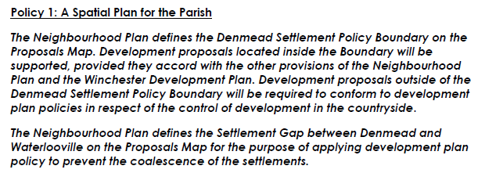 | We have used the settlement boundary quite regularly to defend development outside and prevent ‘sprawl’ along the roads leading into the village. We would like to strengthen the settlement gap between Denmead and Waterlooville as there are many barns that could be converted.  If there is a further housing allocation for Denmead then the boundary will need to be expanded as it was when the NP was developed. | Neighbourhood plans will have to follow the development strategy which is likely to be set at national level and so there is unlikely to be justification for a local plan policy version of the same strategy. There may be an opportunity to review the settlement boundary if needed.
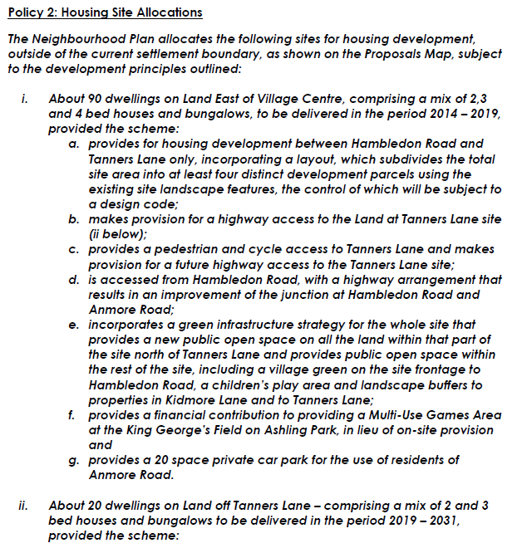  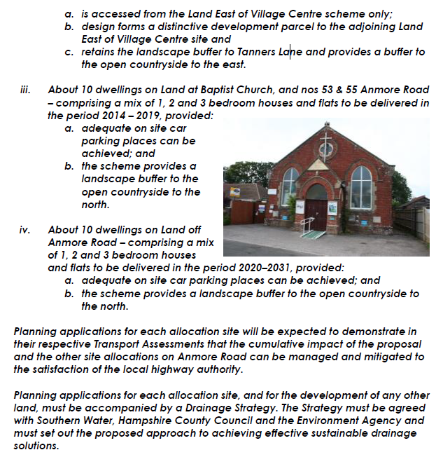 | We successfully used the ‘about 90’ to fend off an application for 99 houses on the Carpenters Field site.  These are yet to come forward. | It is likely that this will be needed in the new NP.  There is not much detail about whether the Government intends to change the neighbourhood plan process but it is likely that he housing number will be allocated to Denmead by the City Council and this will need to be accommodated under the site allocations policy.
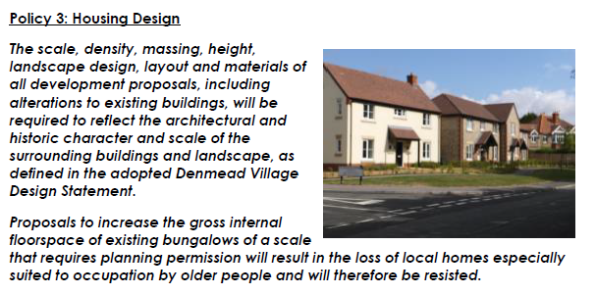 | Whilst WCC supported DPC regarding the design of the new builds on Carpenters Field and insisted on some variation in terms of painted brick, this policy largely hasn’t been supported by WCC. Applications for 3 storey buildings have been approved, as has an application to knock down a small bungalow and rebuild a 4 bedroom property on the plot and an application to convert a bungalow to a place of worship | Matters of design will be incorporated into design codes for the area which could be part of updating the village design statement process.  Likely now that this will be needed in a revised NP.
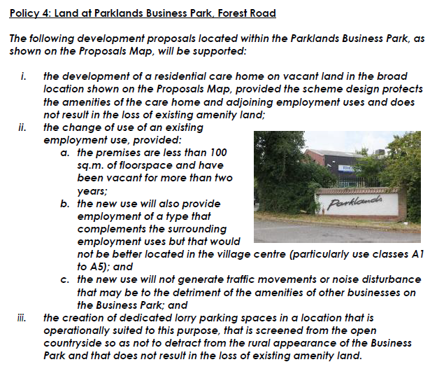 | Over 50% of the business park has now been converted from Office to Residential under the new permitted development rules. | Much of the business use on this site has been lost to permitted development changes to residential. It is not certain that a bespoke policy for this site will be justified. Evidence will be needed if the parish decide that they wish to pursue this.
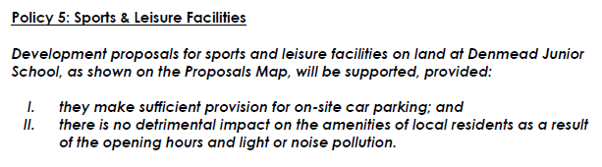 | I don’t believe this is happening. | This is a bespoke local policy which deals with sports and leisure facilities at Denmead Junior School. The retention of this policy could be justified unless the development criteria can be incorporated into a design code. If still needed then it will need to be a new NP policy.
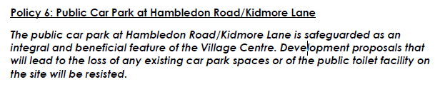 | No applications have been received | This policy seeks to protect the car park and public toilets and could be justified to form part of any new neighbourhood plan.
 | Winchester College have submitted this land for development. They have indicated that they would be willing to provide land directly adjacent to Cemetery Land behind the farmhouse on the corner of Cemetery Lane and Kidmore Lane – however, this land is waterlogged for 60% of the year. | This policy seeks to protect land needed to provide an extension to the cemetery. Its retention in any new neighbourhood plan should be justified / evidenced.  Note from PC comment that the suitability of the site is being questioned therefore further work will be needed on this if it is to be carried forward into the new NP.

